**B.Tech(ECE)**

**Task2-** **Create an example for a product where it needs the following**

**User Research for the Gaming Laptop**

**Objective:** To create a gaming laptop that meets the needs of users looking for high performance, portability, and a sleek design with the latest gaming technologies.

**Key Areas of User Research:**

* **Age and Demographics**: Young adults aged 18-35, mostly male, tech enthusiasts, gamers, and content creators who need high-performance laptops.
* **Pain Points**:
  + **Performance lag** during heavy gaming sessions.
  + **Overheating issues** leading to throttling and performance drops.
  + **Battery life** draining too quickly when gaming.
  + **Bulky designs** not portable enough for on-the-go use.
  + **Poor keyboard response and screen resolution** during long gaming sessions.
* **Expectations**:
  + **High-performance specs**: Top-tier CPUs and GPUs for seamless gaming.
  + **Portability**: A slim and light design.
  + **Long-lasting battery** for extended gaming.
  + **Fast refresh rates** for smoother graphics and faster responses.
  + **Customizable RGB lighting and ergonomic keyboard**.
  + **Advanced cooling systems** to prevent overheating during intensive tasks.
* **Behavior**:
  + **Gaming habits**: Long sessions on high settings, some content creation.
  + **Tech adoption**: Early adopters, tech-savvy individuals who are constantly looking for the latest in hardware and software.

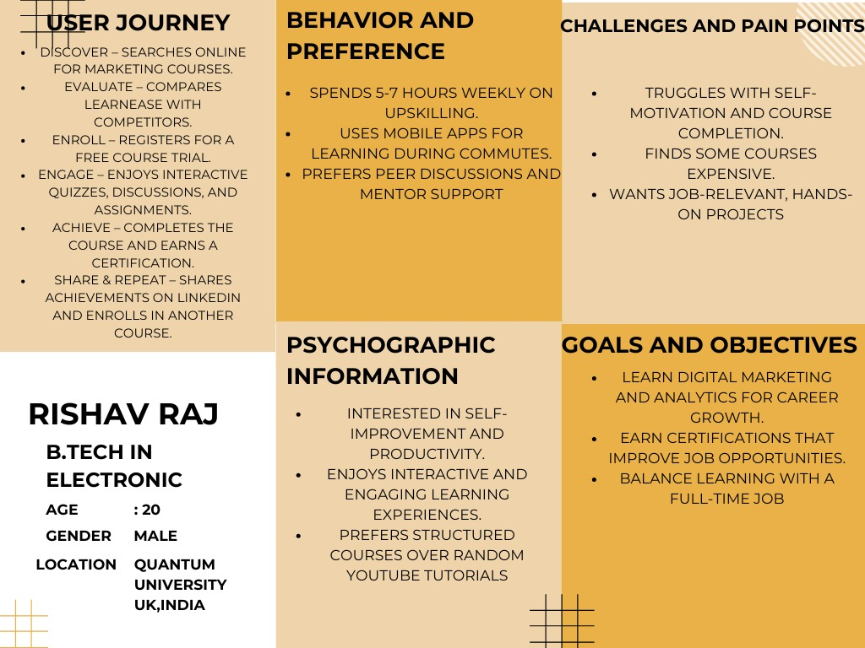

**Journey Mapping for the Product:-**

**Stages of the User Journey:**

1. **Awareness Stage:**
   * **Touchpoints**: Social media ads, influencer recommendations on Twitch, gaming forums, online reviews, tech blogs.
   * **Thoughts/Feelings**: “I need a new laptop for better performance while gaming and streaming.”
   * **Actions**: Alex browses through different brands, reads reviews, and watches YouTube comparisons.
   * **Opportunities**: Create engaging and informative content (e.g., YouTube reviews, influencer partnerships, targeted ads).
2. **Consideration Stage:**
   * **Touchpoints**: Brand website, product specifications page, online reviews, gaming forum threads.
   * **Thoughts/Feelings**: “This looks promising, but I need to be sure it can handle long sessions without overheating.”
   * **Actions**: Alex narrows down the options, checks for thermal benchmarks, battery reviews, and any complaints about the laptop.
   * **Opportunities**: Provide clear specifications and user testimonials. Highlight the cooling system, battery longevity, and multitasking capabilities.
3. **Decision Stage:**
   * **Touchpoints**: Online store, payment gateway, confirmation emails.
   * **Thoughts/Feelings**: “This laptop seems perfect for my needs. I can finally stream and game without performance drops.”
   * **Actions**: Alex makes the purchase through the brand’s website or an e-commerce platform.
   * **Opportunities**: Offer financing options or discounts to encourage conversion. Include a personalized checkout experience.
4. **Post-Purchase Stage:**
   * **Touchpoints**: Product delivery, unboxing experience, first setup instructions, customer support.
   * **Thoughts/Feelings**: “The laptop looks amazing. Let’s get it set up and try it out.”
   * **Actions**: Alex unboxes the laptop, installs necessary software, configures the RGB settings, and starts gaming or streaming.
   * **Opportunities**: Create detailed, easy-to-follow setup guides, video tutorials, and offer quick access to customer support.
5. **Loyalty Stage:**
   * **Touchpoints**: Email marketing, social media, brand community, feedback surveys.
   * **Thoughts/Feelings**: “I love this laptop! I’ll tell my followers about it and return for future upgrades.”
   * **Actions**: Alex shares his experience on social media, participates in gaming forums, and might consider purchasing accessories or future models.
   * **Opportunities**: Build a brand community, offer loyalty rewards or discounts for referrals, encourage Alex to become a brand ambassador